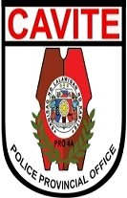

Republic of the Philippines
NATIONAL POLICE COMMISSION
PHILIPPINE NATIONAL POLICE, POLICE REGIONAL OFFICE CALABARZON
CAVITE POLICE PROVINCIAL OFFICE
CARMONA MUNICIPAL POLICE STATION
J.M. Loyola St. Brgy. Maduya, Carmona, Cavite

MEMORANDUM

FOR : Acting Provincial Director
Cavite PPO
(Attn: C, PIDMU)

FROM : Acting Chief of Police

SUBJECT : Monthly Report of Timely Released of PUPCs

DATE : March 02, 2022

- Submitted herewith are the following listed below :
- Recapitulation of Monthly Report Timely Released of PUPCs
- Photocopy of Blotter Entry Number of PUPCs released
- Photocopy of Authority / Reason of Release of PUPCs

- For information.

JOSEPH C CARLIT
Police Major


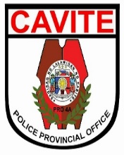
Republic of the Philippines
NATIONAL POLICE COMMISSION
PHILIPPINE NATIONAL POLICE, POLICE REGIONAL OFFICE CALABARZON
CAVITE POLICE PROVINCIAL OFFICE
CARMONA MUNICIPAL POLICE STATION
J.M. Loyola St., Brgy.Maduya, Carmona, Cavite

Monthly Report of Timely Release of PUPCs
February 2022 RECAP

Number of PUPC with Release Order | Number of Release Order | Number of Release on Time | Number of Delayed Release | Remarks/Reasons for the Delayed
11 | 11 | 11 | 0 | 0

Prepared by :

PSSg Percival Restrivera
Custodial Officer

